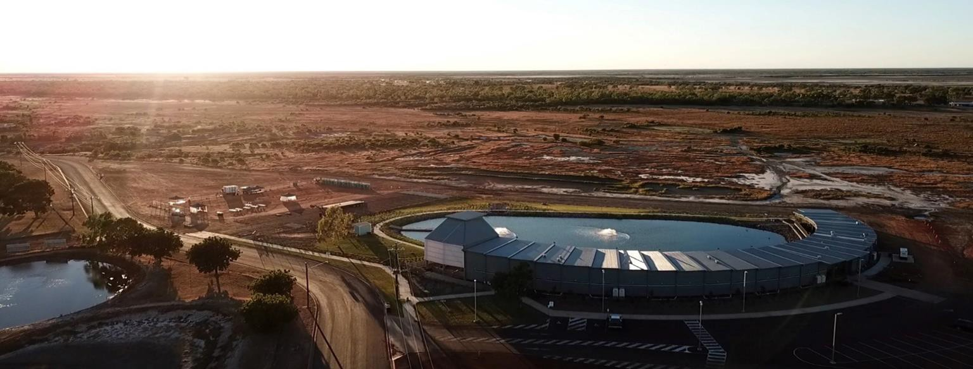Carpentaria Shire Council
Australia Day Nomination Form

About the Australia Day Awards
The Carpentaria Shire Council Australia Day Awards celebrate the hard work and commitment of individuals, community groups and events throughout our Shire. These awards give an opportunity to publicly recognise and celebrate those who are doing wonderful things in our community.

This form is available online at www.carpentaria.qld.gov.au or hard copies are available at Council Administration Office, Gallagher Butchery, Normanton Stop Shop, Normanton Post Office, Normanton Traders, Karumba Supermarket, Les Wilson Barramundi Discovery Centre.

Please submit completed forms and documentation by: Delivering to
Australia Day Awards Carpentaria Shire Council 33 Haig Street
Normanton QLD 4890

Mailing to
Australia Day Awards Carpentaria Shire Council PO Box 31
Normanton QLD 4890

Emailing to
Australia Day Awards council@carpentaria.qld.gov.au

Please contact Carpentaria Shire Council on (07) 4745 2200 for further information Key Dates
- Monday 9th January 2023 Nominations Close
- Thursday 26 January 2023 Australia Day Awards presentation and celebration
*please note that nominations will be open year-round and can be submitted electronically through Council’s website, or in hard copy form via email, post or hand delivery. Hard copy forms are also available on Council’s Website.

Privacy Notice
Carpentaria Shire Council is collecting the personal information you supply on this form for the purpose of processing your entry for the 2023 Australia Day Awards. Your personal details will not be disclosed to any other person or agency external to Council without your consent unless required or authorised by law.

Please read the following criteria carefully and in full before submitting your application.

Award Categories and Criteria
- Citizen of the Year
  - Must be 28 years of age or over as at 26 January 2023.
  - Someone that has contributed to the community in a beneficial way, in a
voluntary basis, and not within the person’s paid work or job commitments.
  - Winner of this award will become the Carpentaria Shire Ambassadors until 26
January 2024
- Young Citizen of the Year
  - Must be aged between 16 and 27 years old as at 26 January 2023
  - Someone that has contributed to the community in a beneficial way, in a
voluntary basis, and not within the person’s paid work or job commitments.
  - Winner of this award will become the Carpentaria Shire Ambassadors until 26
January 2024
- Sports Administrator of the Year*
  - This award can be given to a person of any age
  - The aim of the Sports Administrator award is to recognise a person who has
made a significant contribution in Carpentaria Shire to sport as a coach, official, administrator and/or a mentor/trainer. The nominee’s contributions will have been completed on a voluntary basis or exceeding the normal requirements of their paid work.
  - All sports will be considered
- Senior Sports Person*
  - Must be 18 years or over as January 26 January 2023
  - The aim of this award to recognise outstanding and noteworthy record of
achievement in sports.
  - Residents who attend or have attended Boarding School or other further
education outside of the Carpentaria Shire are still eligible.
- Junior Sports Person* **
  - Must be under 18 years of age as at January 2023
  - The aim of this award to recognise outstanding and noteworthy record of
achievement in sports.
  - Residents who attend or have attended Boarding School or other further
education outside of the Carpentaria Shire are still eligible.
*Junior Sports Person, Senior Sports Person and Sports Administrator in the Carpentaria Shire will be nominated by the Australia Day Council Committee in the North Queensland Sports Foundation 2023 Sports Star Awards
** Junior Sports Person of the Year winner will be nominated by Council for the North Queensland Sports Development Bursaries in 2023.
- Community Event of the Year
  - This award is given in recognition of hosting an event in 2022, and that made
a significant contribution or exceptional achievement in Carpentaria Shire.

- Arts/Cultural Award
  - This award is to recognise individuals/organisations that have produced,
promoted, or taught in arts and culture. Examples can include painting, music, photography, cultural awareness, sculptures.
  - This award is open to individuals of any age as well as organisations
- The Mayor’s Award
  - This award is to acknowledge the quiet achievers of Carpentaria Shire. They will
have shown ambition, self-motivation, and dedication by pursuing different opportunities for themselves and/or others in the community.
  - This award will be judged by the Mayor only

Criteria
- Nominees MUST be a resident of the Carpentaria Shire
- Nominations may be submitted by groups (for example, committees, associations, schools, so on) or individuals, with or without the knowledge of the persons being nominated.
- The nature of the Citizen Awards places emphasis on what the person has/had done for the community in their various fields of involvement, rather than:
- recognising personal achievements and/or ambitions (except where the
personal achievement has brought recognition to the Carpentaria community and has engendered community pride); or
- what they may have done as part of the normal duties in their occupation
(except where the nominee's achievements are above and beyond what is expected in an individual's normal duties).
- Awards will not be granted posthumously.
- Self-nominations of individuals will not be accepted
- Nominees must comply with age restrictions specified in award categories. o If nominee are nominated in the wrong category, nominators will be notified. o Unsuccessful nominees may be re-nominated in subsequent year
- Uncompleted forms or short sentence wording will not be accepted

Judging
- Australia Day awards will be considered by a committee. The committee will consist of the Mayor, six Councillors and elected community members from both Normanton and Karumba
- The committee may determine that no nominee is suitable for an award in a category
- The committee reserves the right to transfer nominees to other categories based on appropriateness
- The decision of the committee will be final, and no correspondence will be entered into
- The judging of candidates will be based on the information provided in the nomination
- The Committee may choose to contact referees listed in this nomination form

The selection panel will also consider the following in assessing and comparing nominations against the above criteria
- Personal, academic, sporting, and professional achievements awards and recognition
- Contribution to the relevant field (how has the nominee ‘put back’ into their field to
benefit others)
- Demonstrated leadership, innovation, and creativity
- Future goals and likely impact
- Nature of activity or service
- Achievements as an individual or as part of a group or organisation

Nomination Form

Nominate a category:
- Citizen of the Year
- Young Citizen of the Year
- Sports Administrator of the Year
- Senior Sports Person of the Year
- Junior Sports Person of the Year
- Community Event/Organisation of the Year
- Arts/Cultural Award
- The Mayors Award

Nominee: (this section MUST be completed)
Full Name
Age at 26 January 2023 | UNKNOWN
Or provide details of Community Event or Committee
Event/Committee Name

Nominee Details: (this section MUST be completed)
Postal Address
State |  | Postcode
Home Phone Number
Mobile Phone Number
Occupation
Email Address
Gender
Is the nominee an Australian Citizen

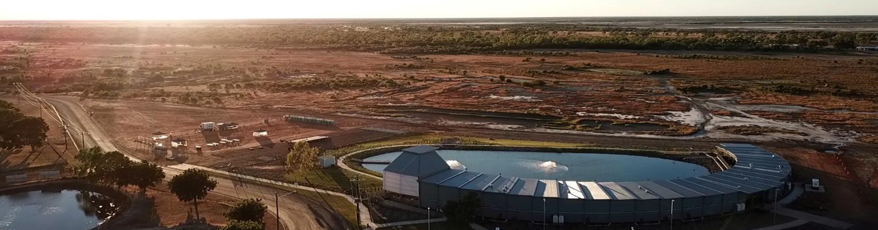Reason/s for Nomination
Form 4A
Carpentaria Shire Council
Australia Day Nomination Form
In choosing the recipients of the Australia Day Awards, regard is given to the nominee’s achievements in the year immediately prior to receiving the award, as well as their past achievements and ongoing contribution to the Australian community and nation.

An individual need only be nominated once to be considered. The number of nominations received per nominee bears no weight in their selection.

Please provide as much information as you can. Make sure to mention:
- In what role(s) or area(s) has the nominee excelled
- Significant contribution to the Carpentaria community and wider networks
- An inspirational role model for the Carpentaria community and wider networks.

How has the person/event/organisation made an outstanding contribution to the community?

Form 4A
Carpentaria Shire Council
Australia Day Nomination Form

How is the person/event/organisation an inspiration for the community?

Why should this person’s/event’s/organisation’s contributions be recognised by an Australia
Day Award?

If nominating for sports awards please list level of achievement in the sport i.e regional titles etc.

Supporting Documentation
Council encourages you to include supporting documents such as photographs and press articles. By providing this documentation the panel will have a much better understanding of why you think your nominee should be selected for an award.

Please list supporting documents below and attach clear copies only, no originals and no more than ten (10) pages of supporting documentation
Please list below all supporting documents attached
1
2
3
4
5

Nominee Referee
Details of referee who can make a direct comment on nominee
Full Name
Postal Address
State |  | Postcode
Home Phone Number
Mobile Phone Number
Occupation
Email Address

Nominator Details (details of person submitting this nomination)
Full Name
Postal Address
State |  | Postcode
Home Phone Number
Mobile Phone Number
Occupation
Email Address

